**MYSQL PRACTICE QUESTIONS**

**SUBMITED BY-:**

**STUDENT NAME -: PALLAVIUPADHYAY**

**ENROLL NO-: 23BCT0008**

**SUBJECT -: DATABASE DESIGN (MYSQL)**

1. **Insert a new student with the following details: ID = 2, Name = 'Jane Smith', Age = 22, and Grade = 'A' into the student table.**

**QUERY-->**



**INPUT:**

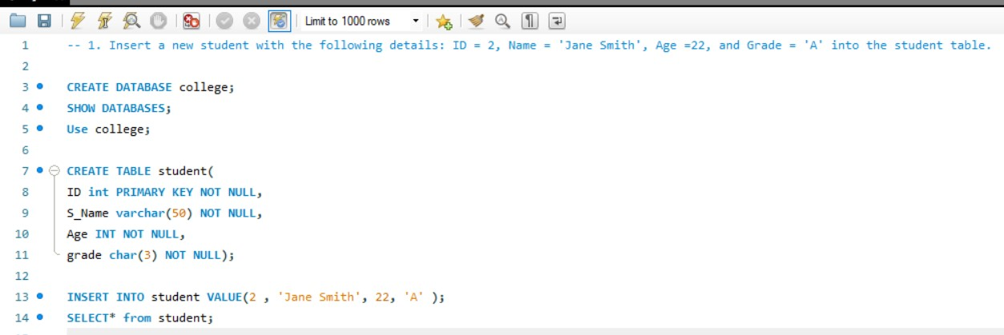

**OUTPUT:**

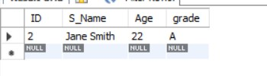

1. **Insert a record into an employees table with columns emp_id, emp_name, department, and salary. Insert emp_id = 101, emp_name = 'Alice', department = 'HR', and salary = 50000.**

**QUERY ->**



**INPUT:**

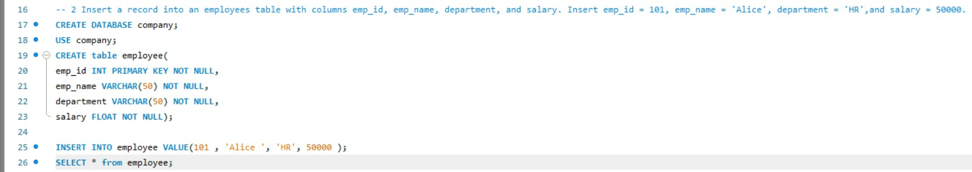

**OUTPUT:**



1. **Insert multiple records into the student table in a single query. Insert one student with ID = 3, Name = 'Mark', Age = 23, Grade = 'B' and another student with ID = 4, Name = 'Lisa', Age = 21, Grade = 'A'.**

**QUERY ->**



**INPUT:**

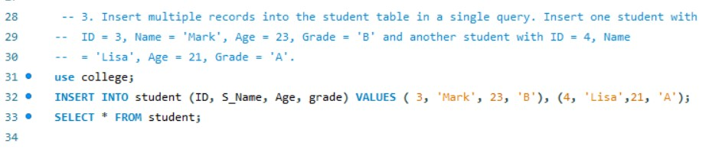

**OUTPUT:**

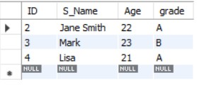

1. **Add a new book to the books table with BookID = 101, Title = 'MySQL Essentials', Author = 'John Doe', Price = 29.99.**

**QUERY ->**

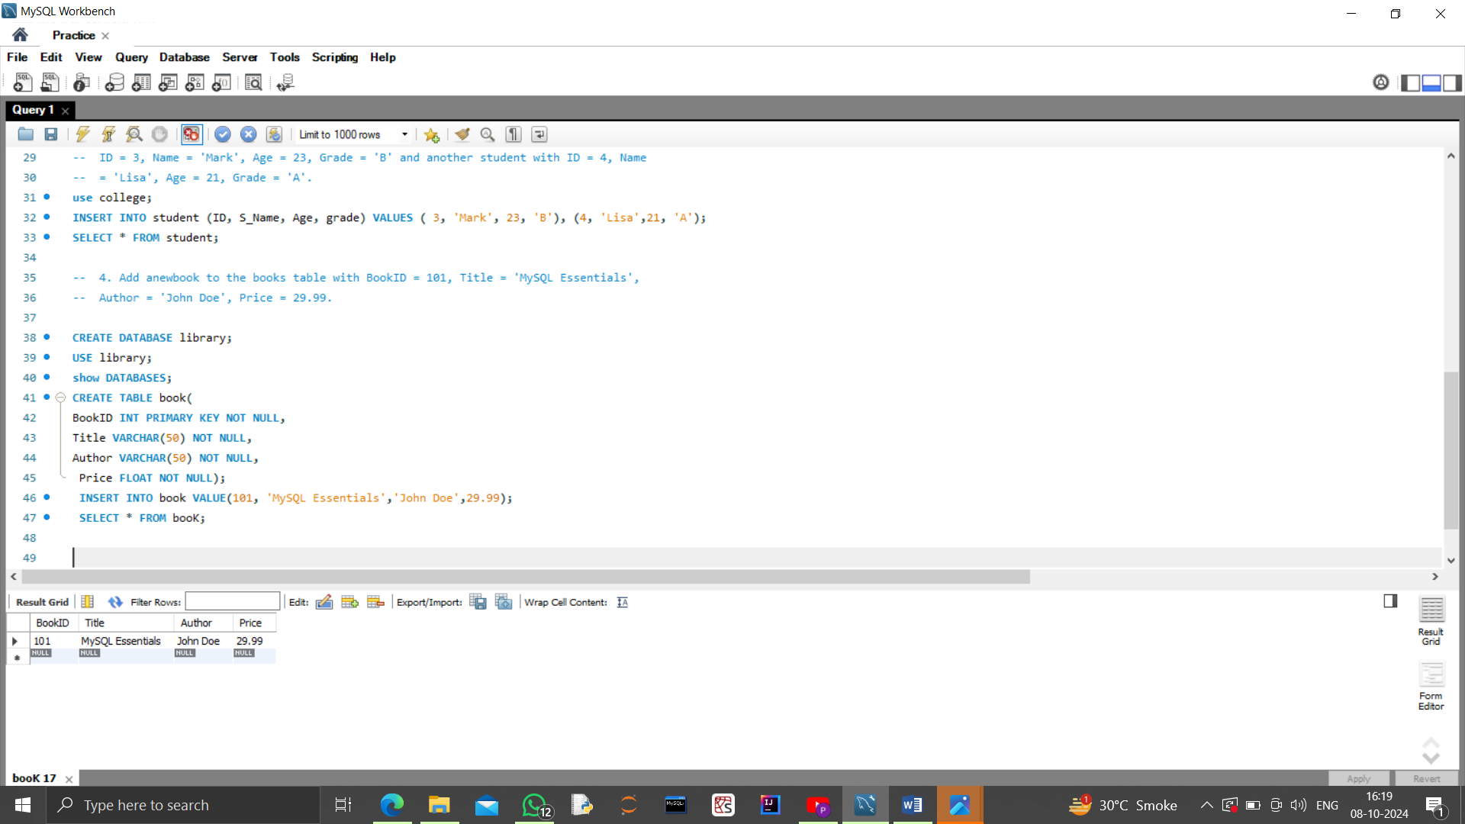

**INPUT:**



**OUPUT:**



1. **Retrieve all the students from the student table**

**QUERY ->**

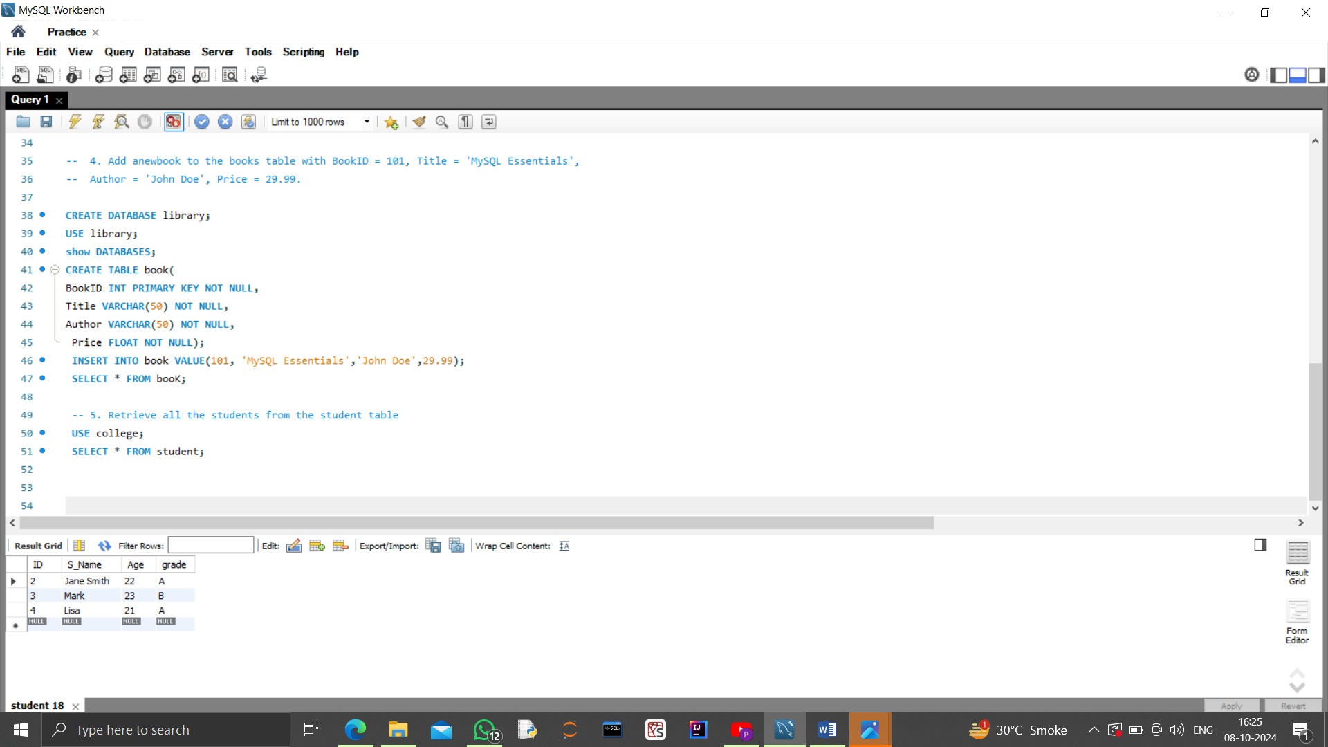

**INPUT:**



**OUTPUT:**



1. **Get the names and majors of all students who are 21 years old or older from the student table**

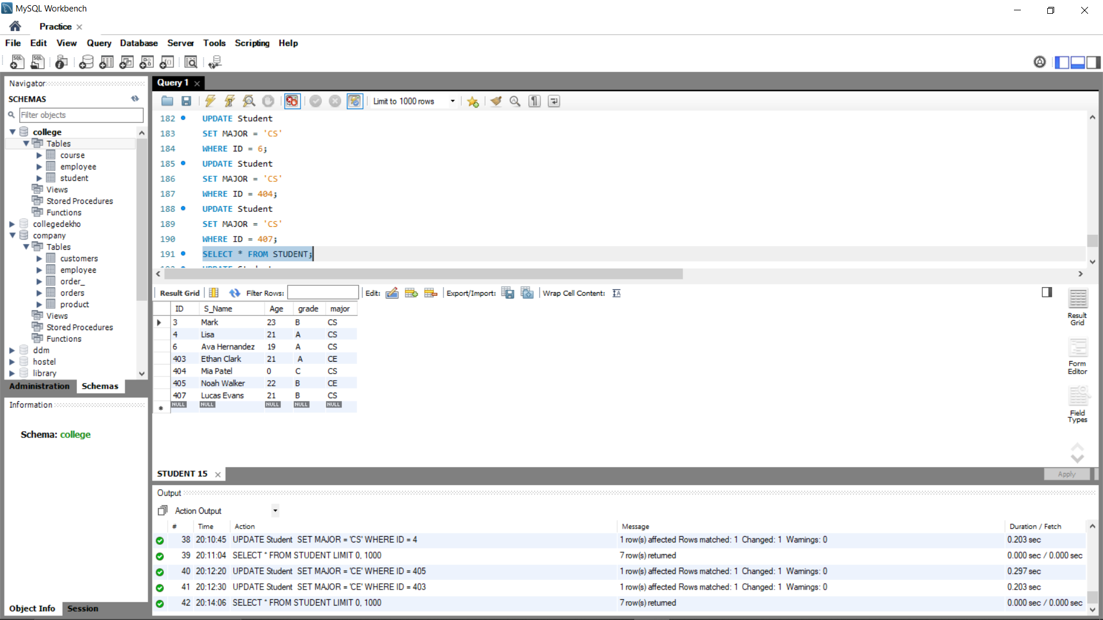

**QUERY->**

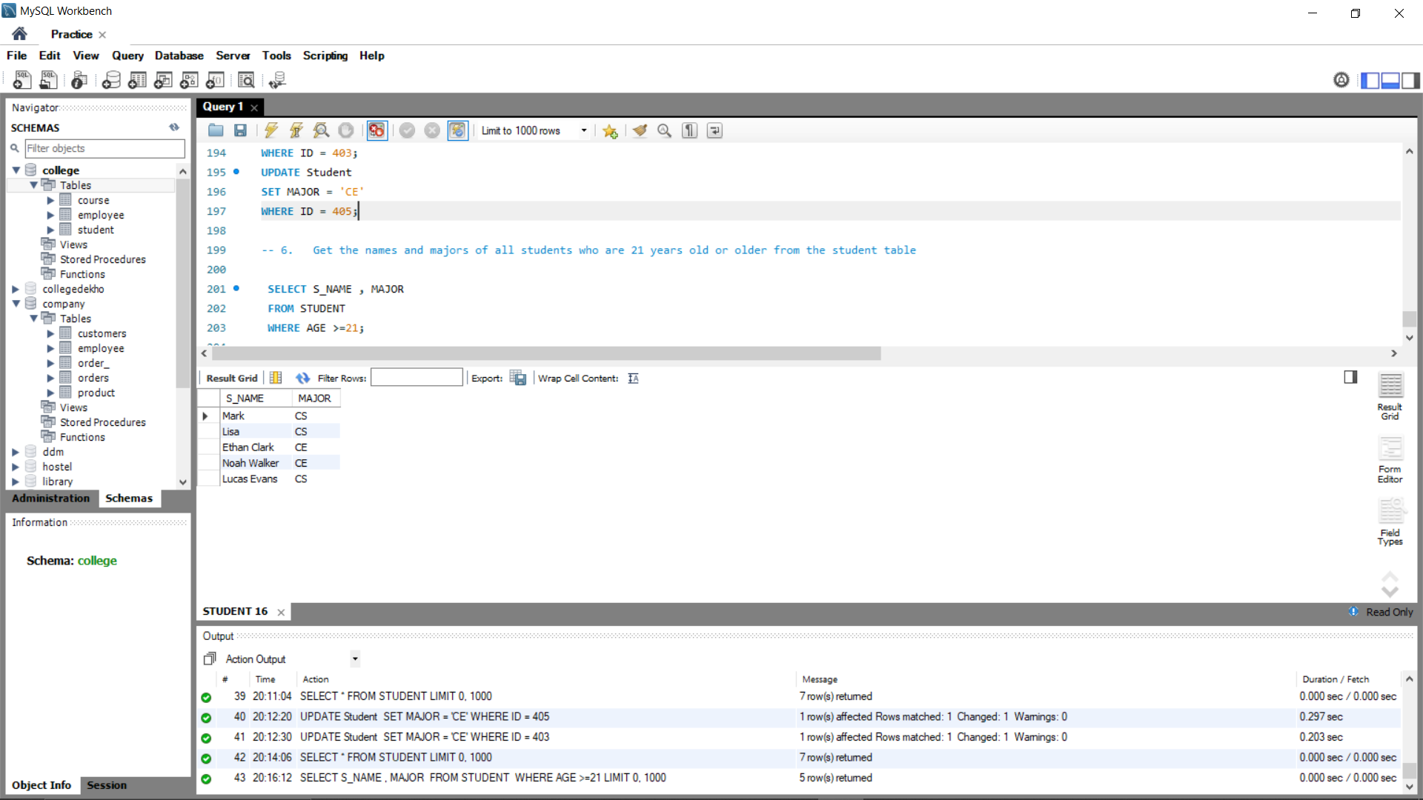

**OUTPUT:**



1. **Select all books from the books table that cost more than 20 dollars**

**QUERY ->**

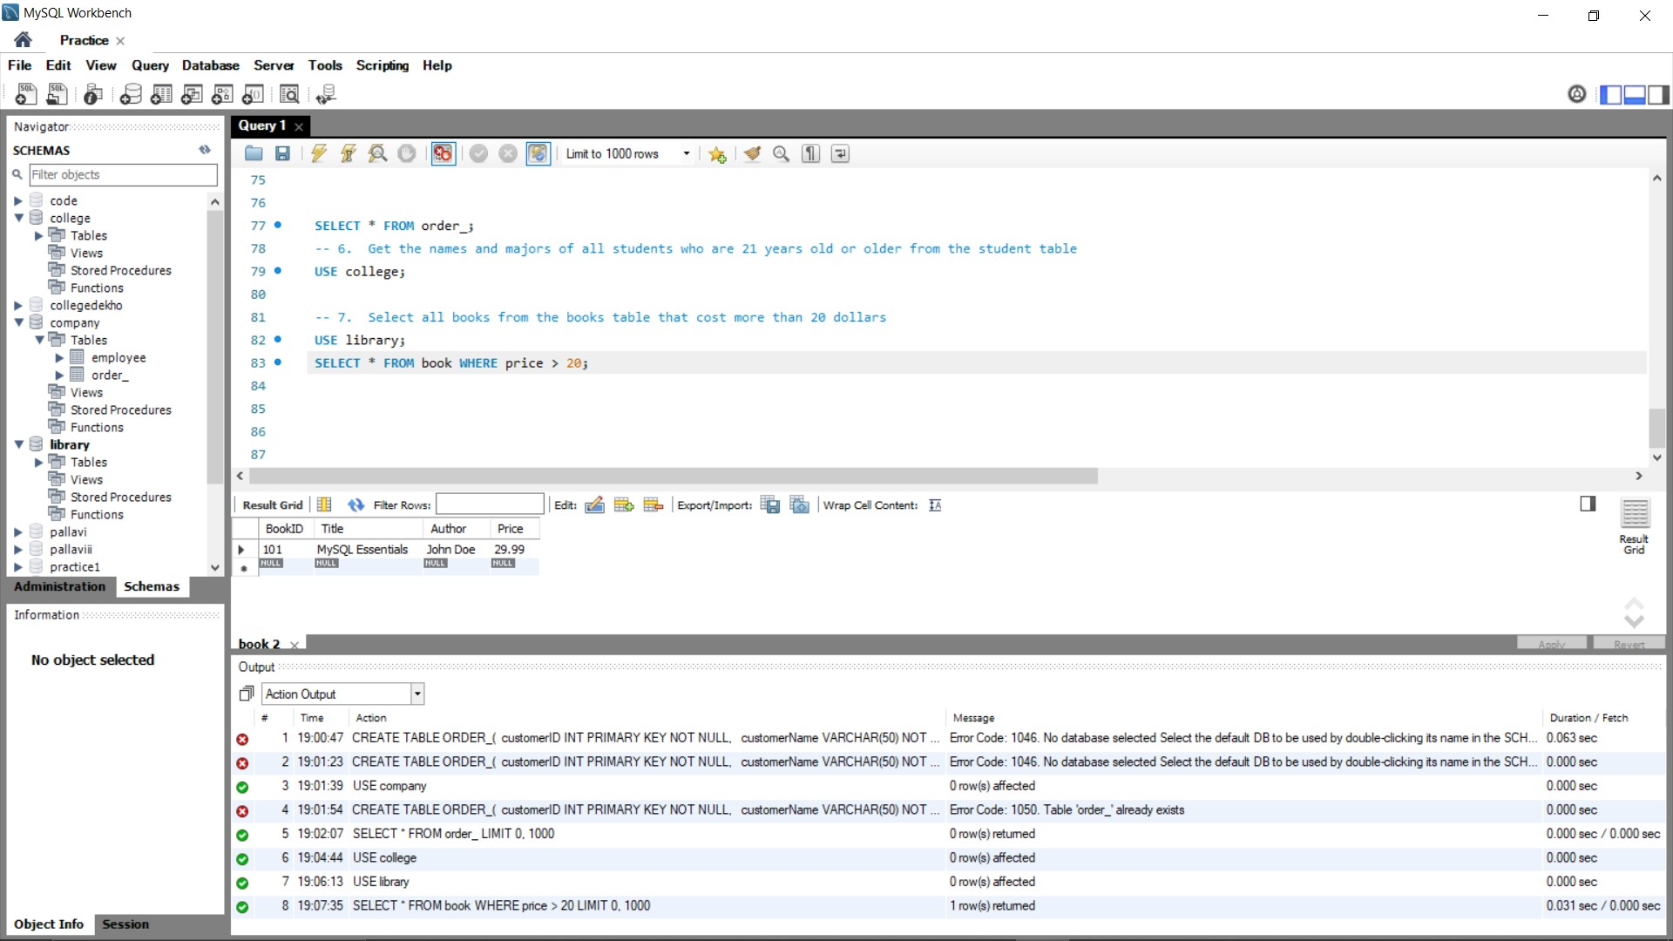

**OUTPUT:**



1. **Retrieve all customers who have placed at least one order from the orders table. Display their CustomerID, CustomerName, and the TotalAmount of their first order (earliest by date**).

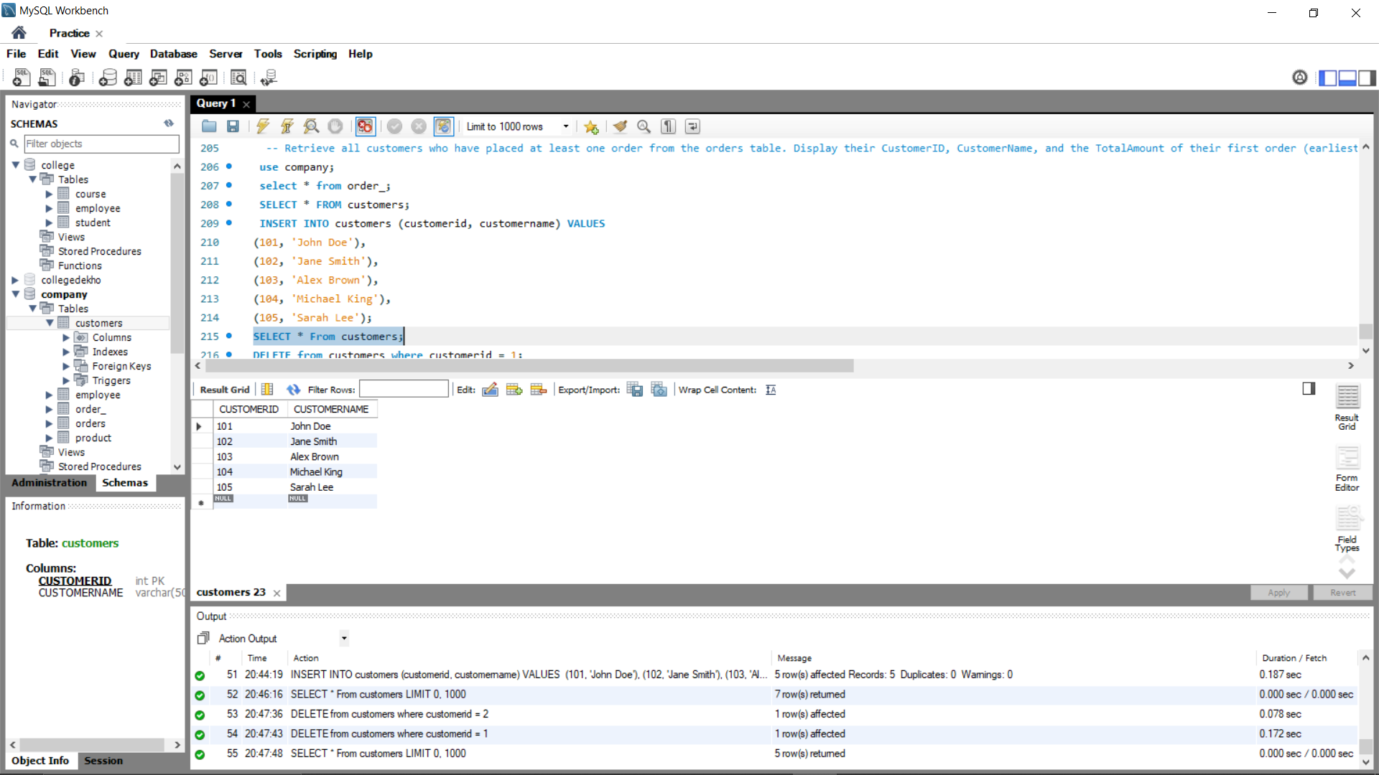 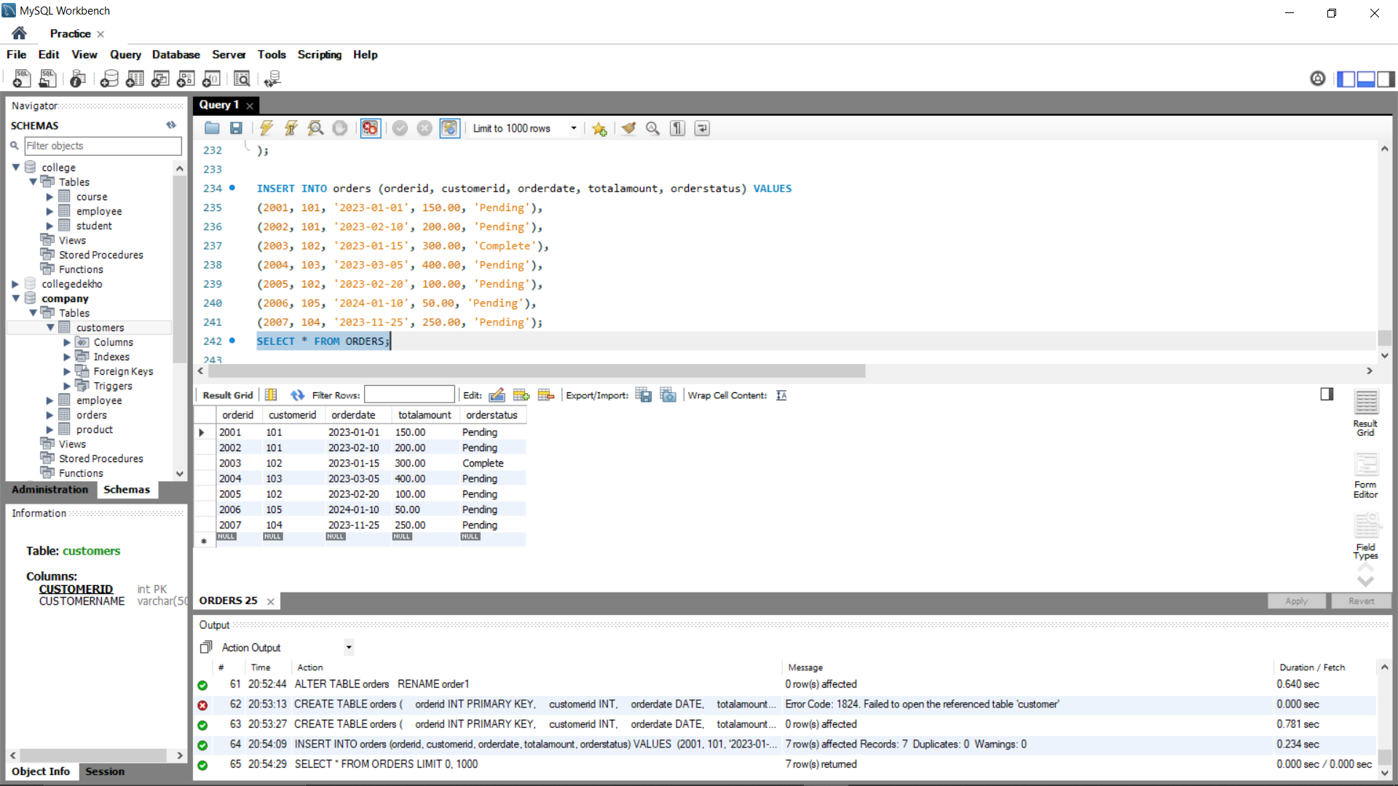

**CUSTOMERS TABLE ORDERS TABLE**

**QUERY->**

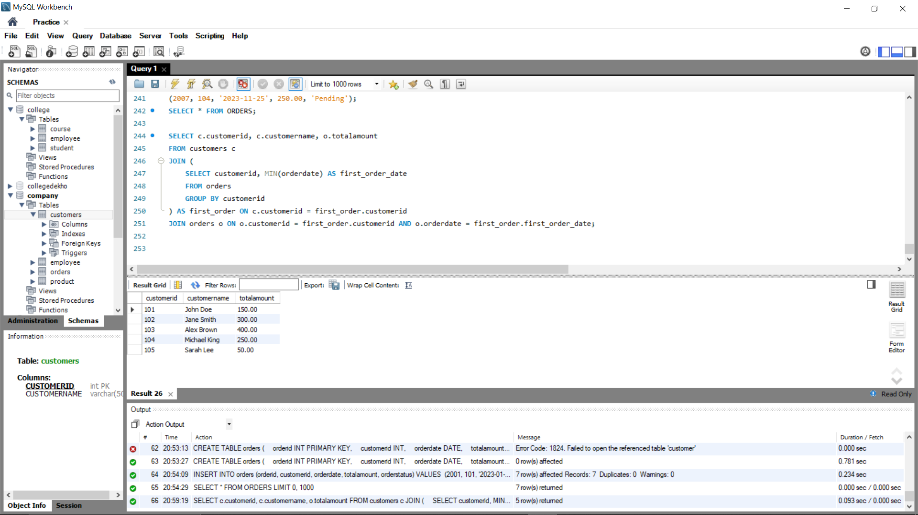

OUTPUT:



1. **List the names of employees who earn more than the average salary in the employees table.**

**QUERY-:**

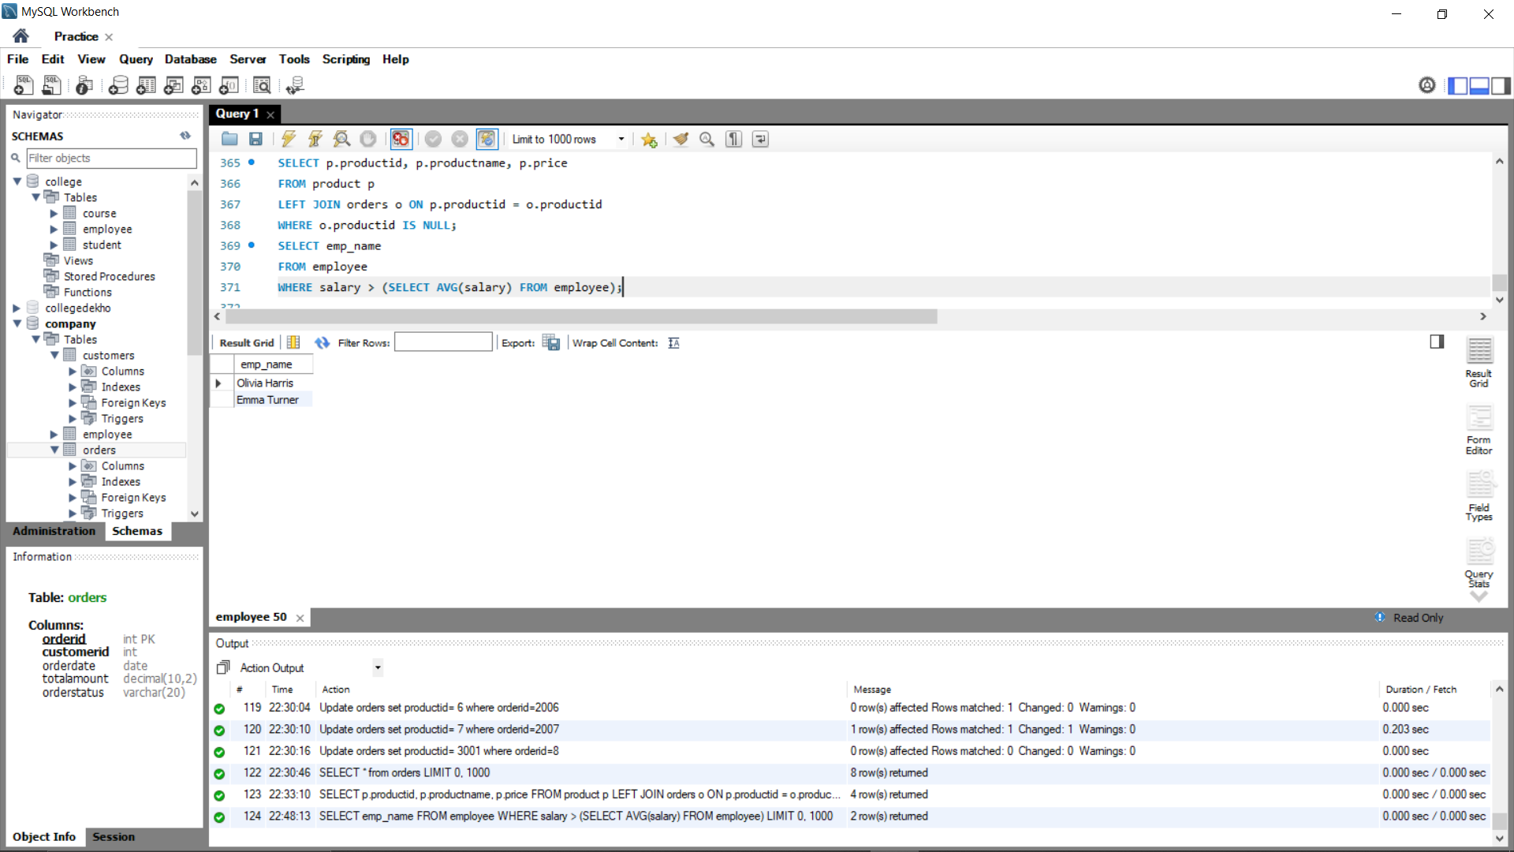

**OUTPUT:-**



1. **Retrieve all products from the products table that have never been ordered. Display the ProductID, ProductName, and Price.**

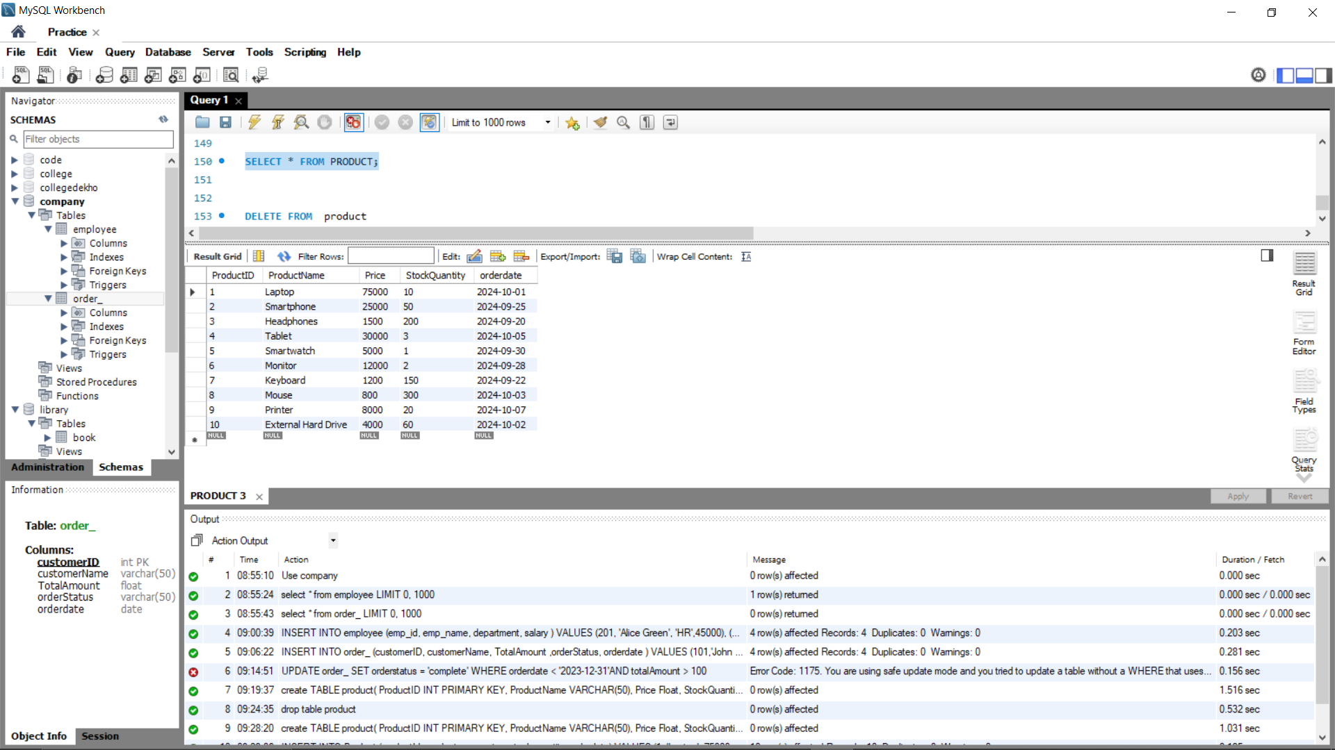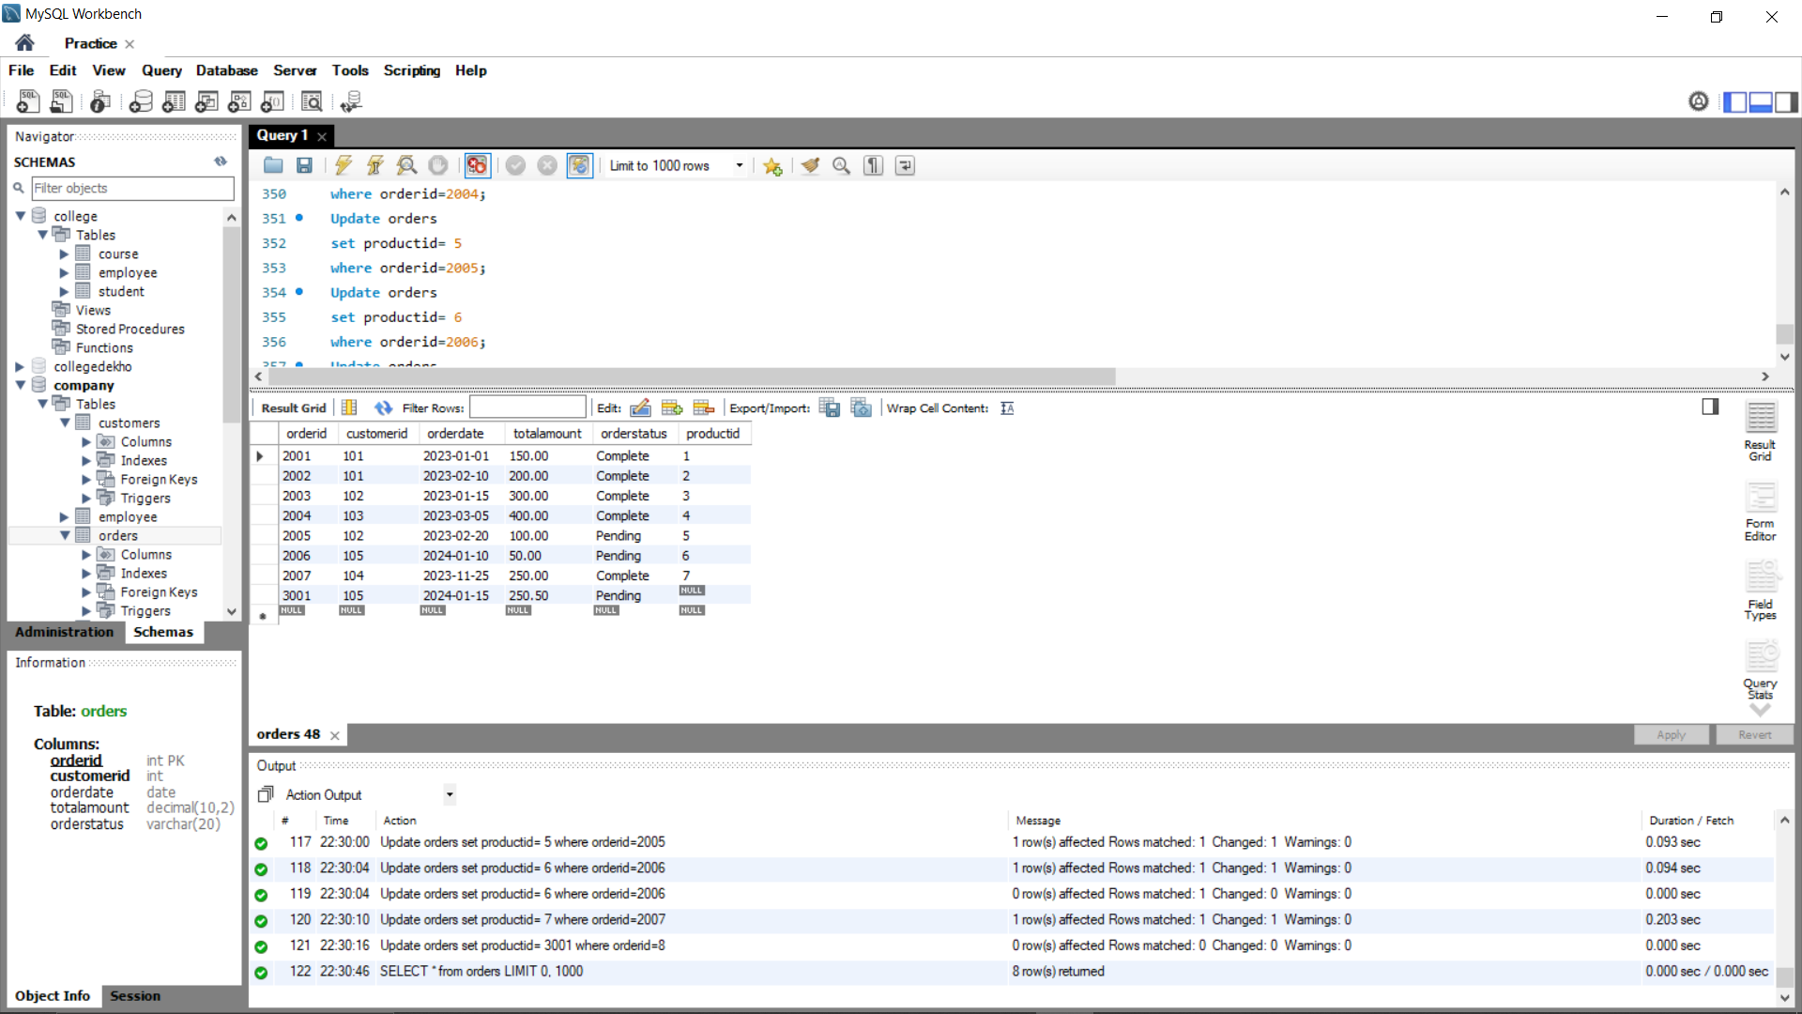

**Product table orders table**

**Query->**

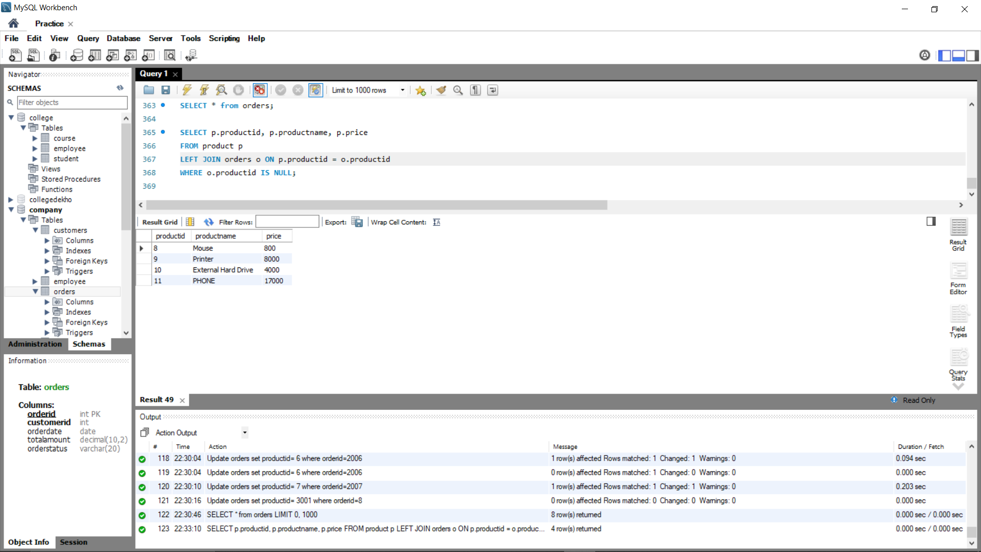

**Output:-**



1. **For each CustomerID, show the total number of orders they have placed, the total amount spent, and the average amount spent per order**



**QUERY->**

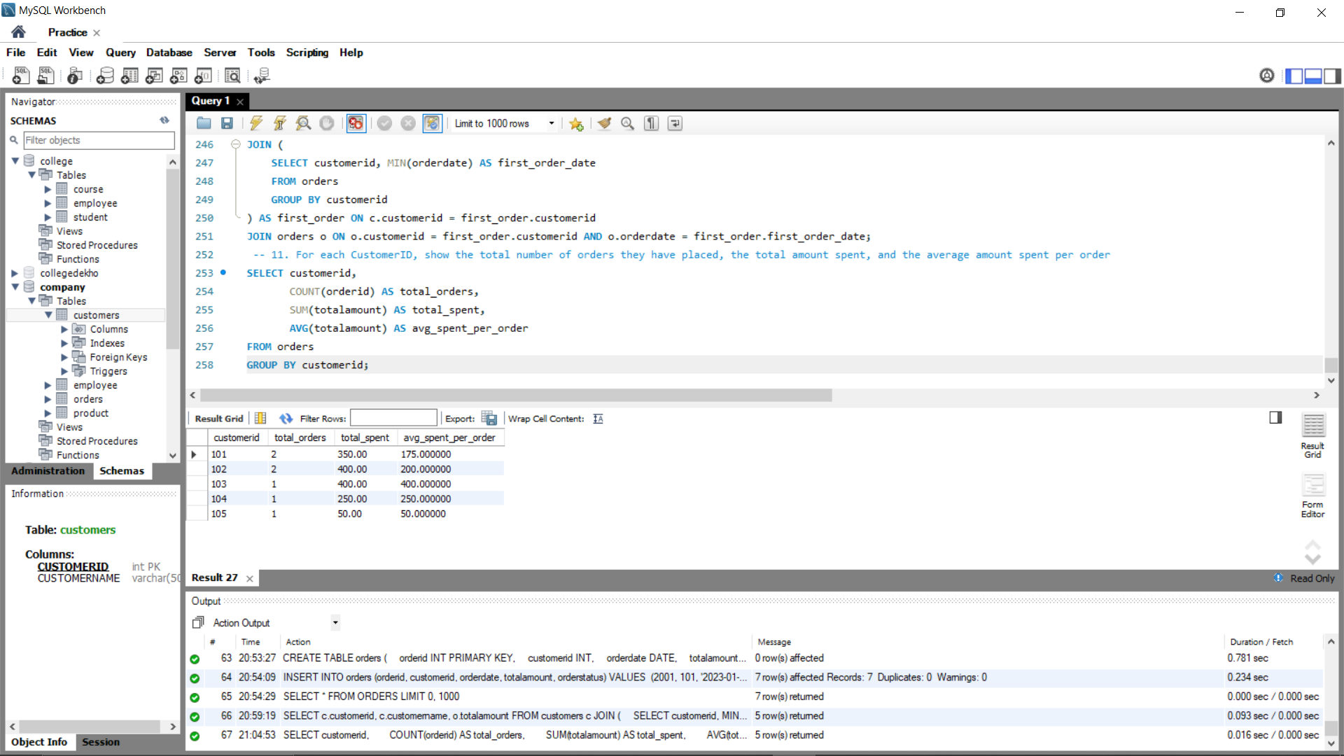

**OUTPUT:**



1. **Update the age of the student whose ID = 1 to 21 in the student table.**

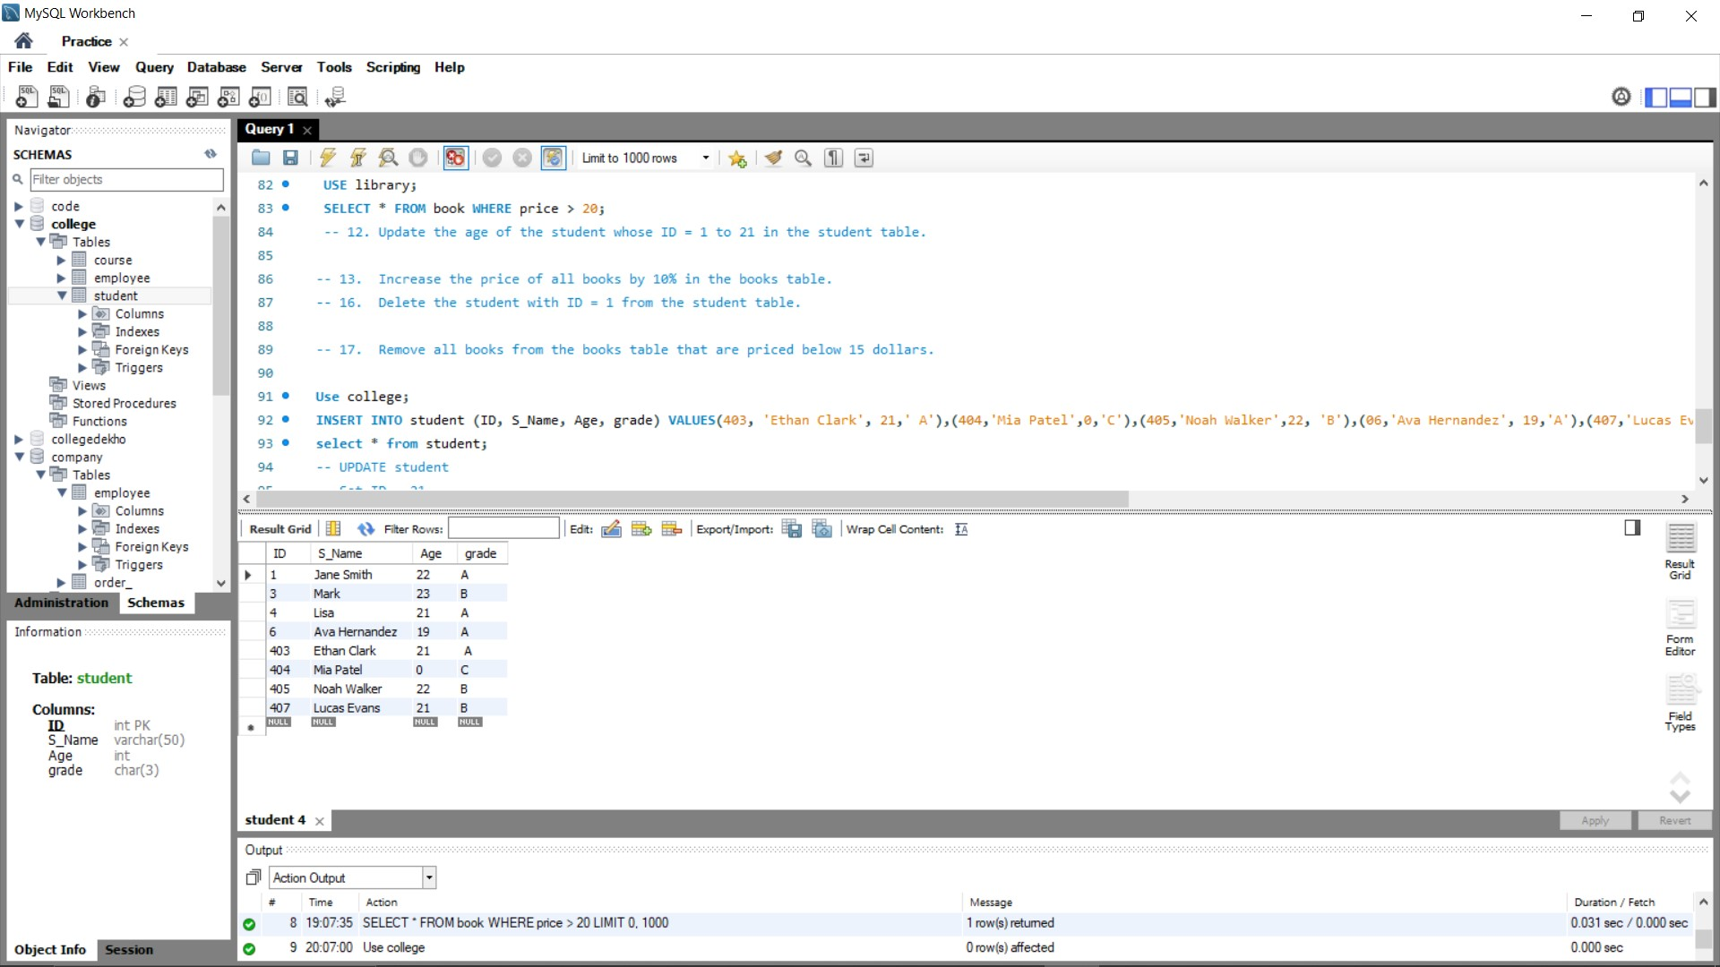

**ANS->**

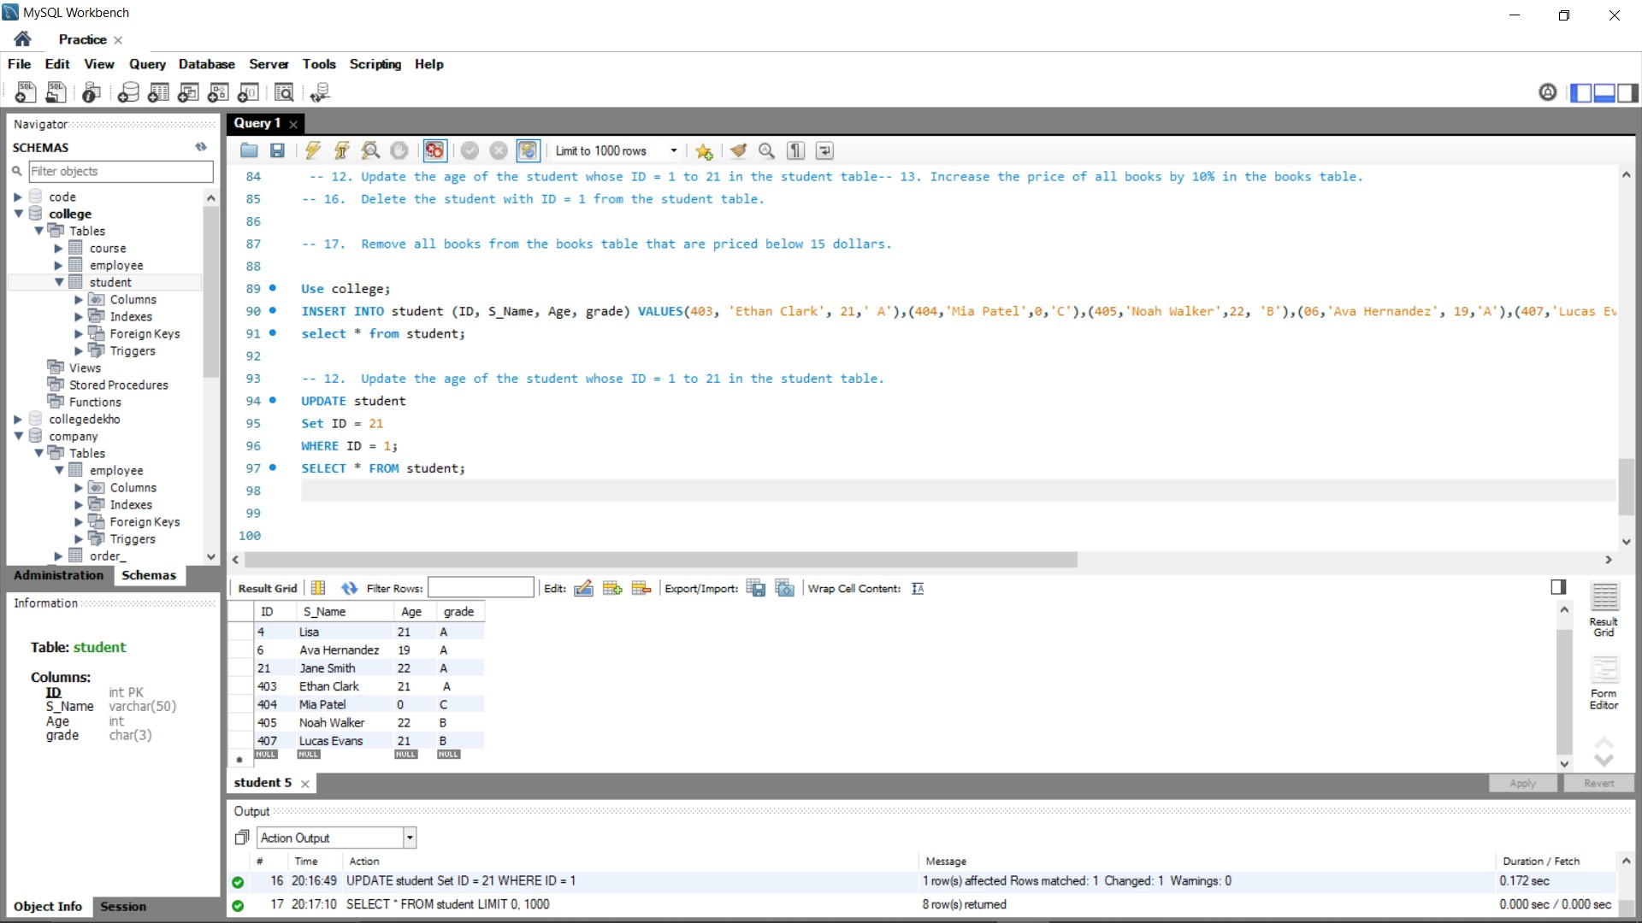

**OUTPUT:**



1. **Increase the price of all books by 10% in the books table.**

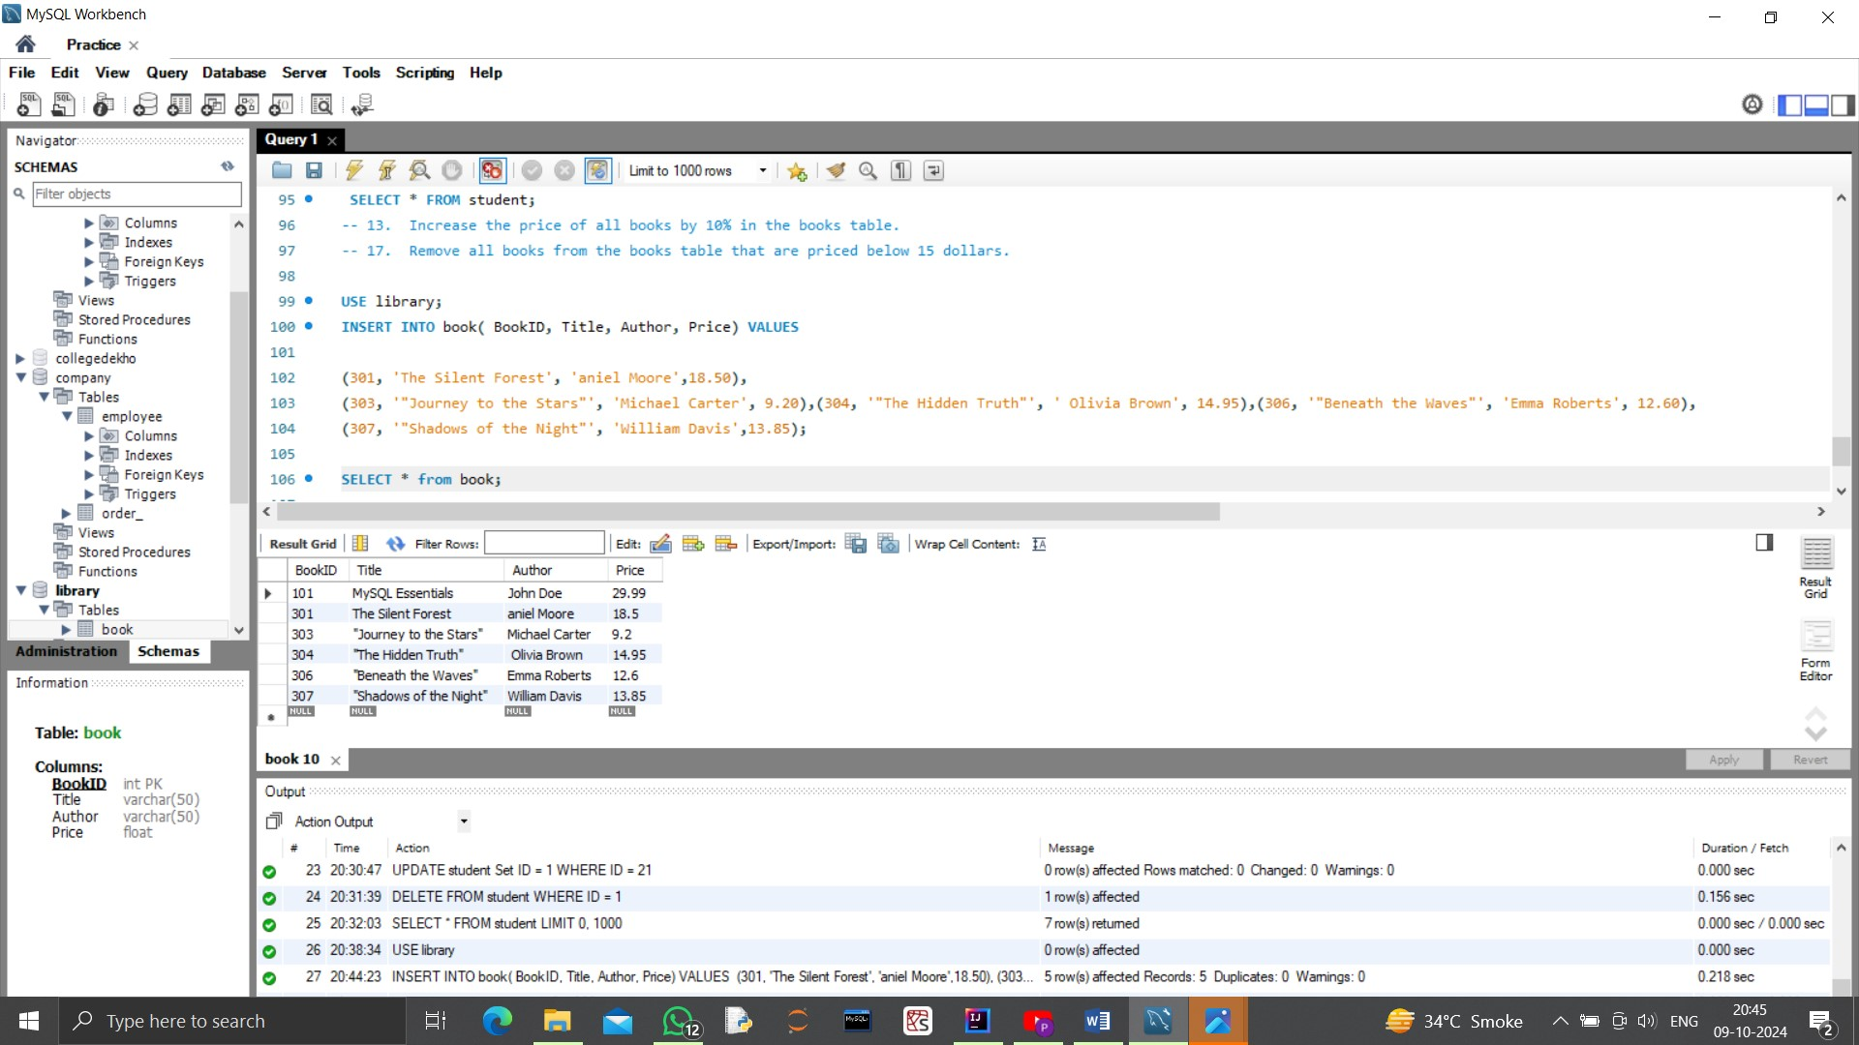

**QUERY->**

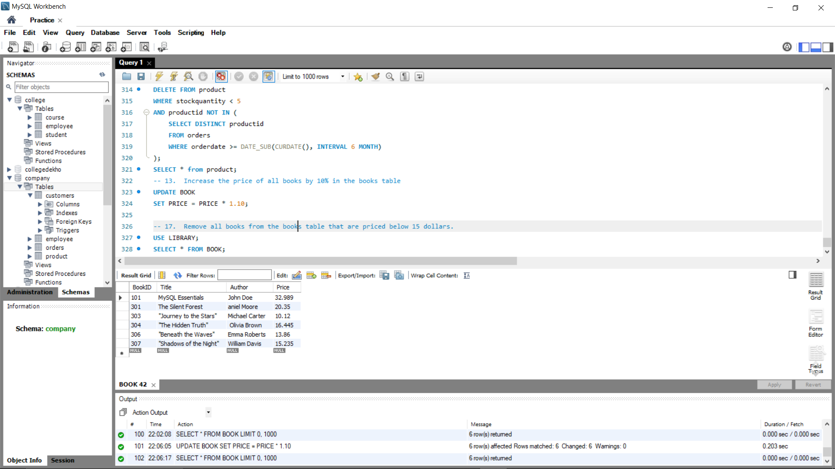

**OUTPUT:-**



1. **Increase the salary of employees who have been in the employees table for more than 5 years by 10%. Assume there's a column HireDate in the table, and only those hired before 2019-09-30 should get the raise**.

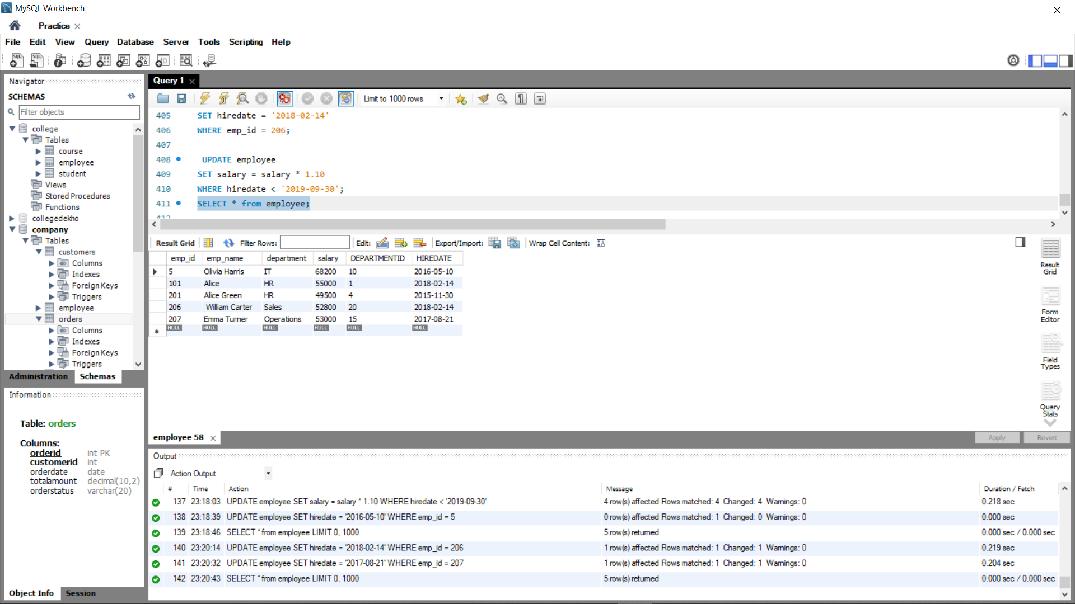

**QUERY-:**



**OUTPUT-:**



1. **Change the OrderStatus to 'Completed' for all orders in the orders table that were placed before 2023-12-31 and whose TotalAmount is greater than 100**



**QUERY -:**

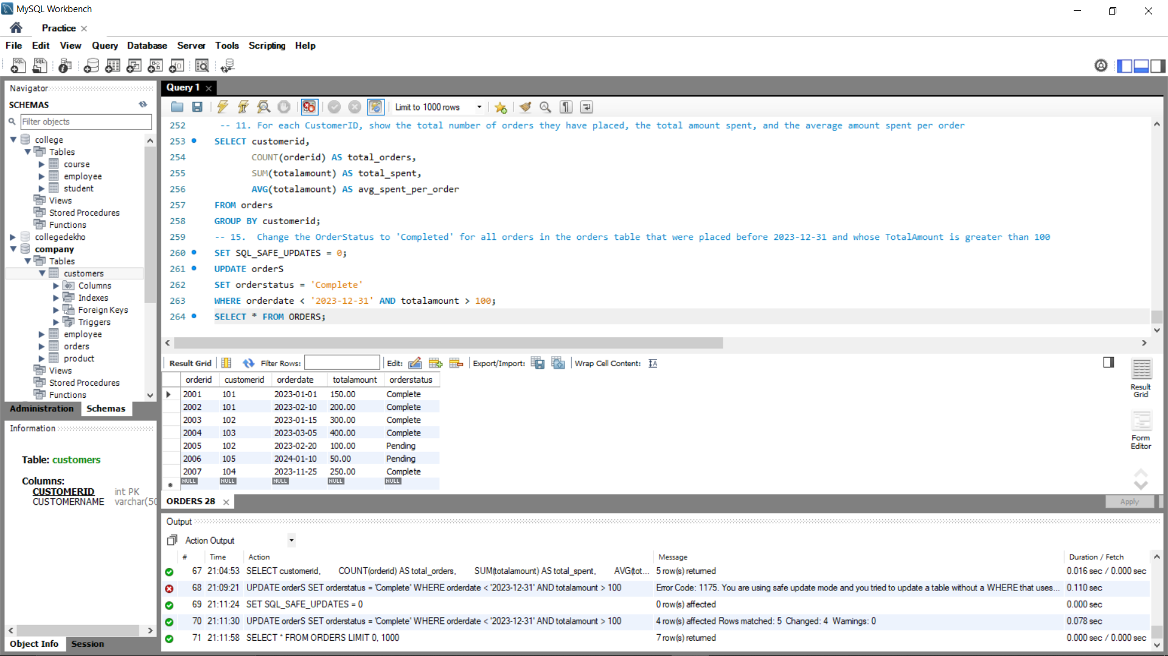

**OUTPUT:-**



1. **Delete the student with ID = 1 from the student table**.



**QUERY->**

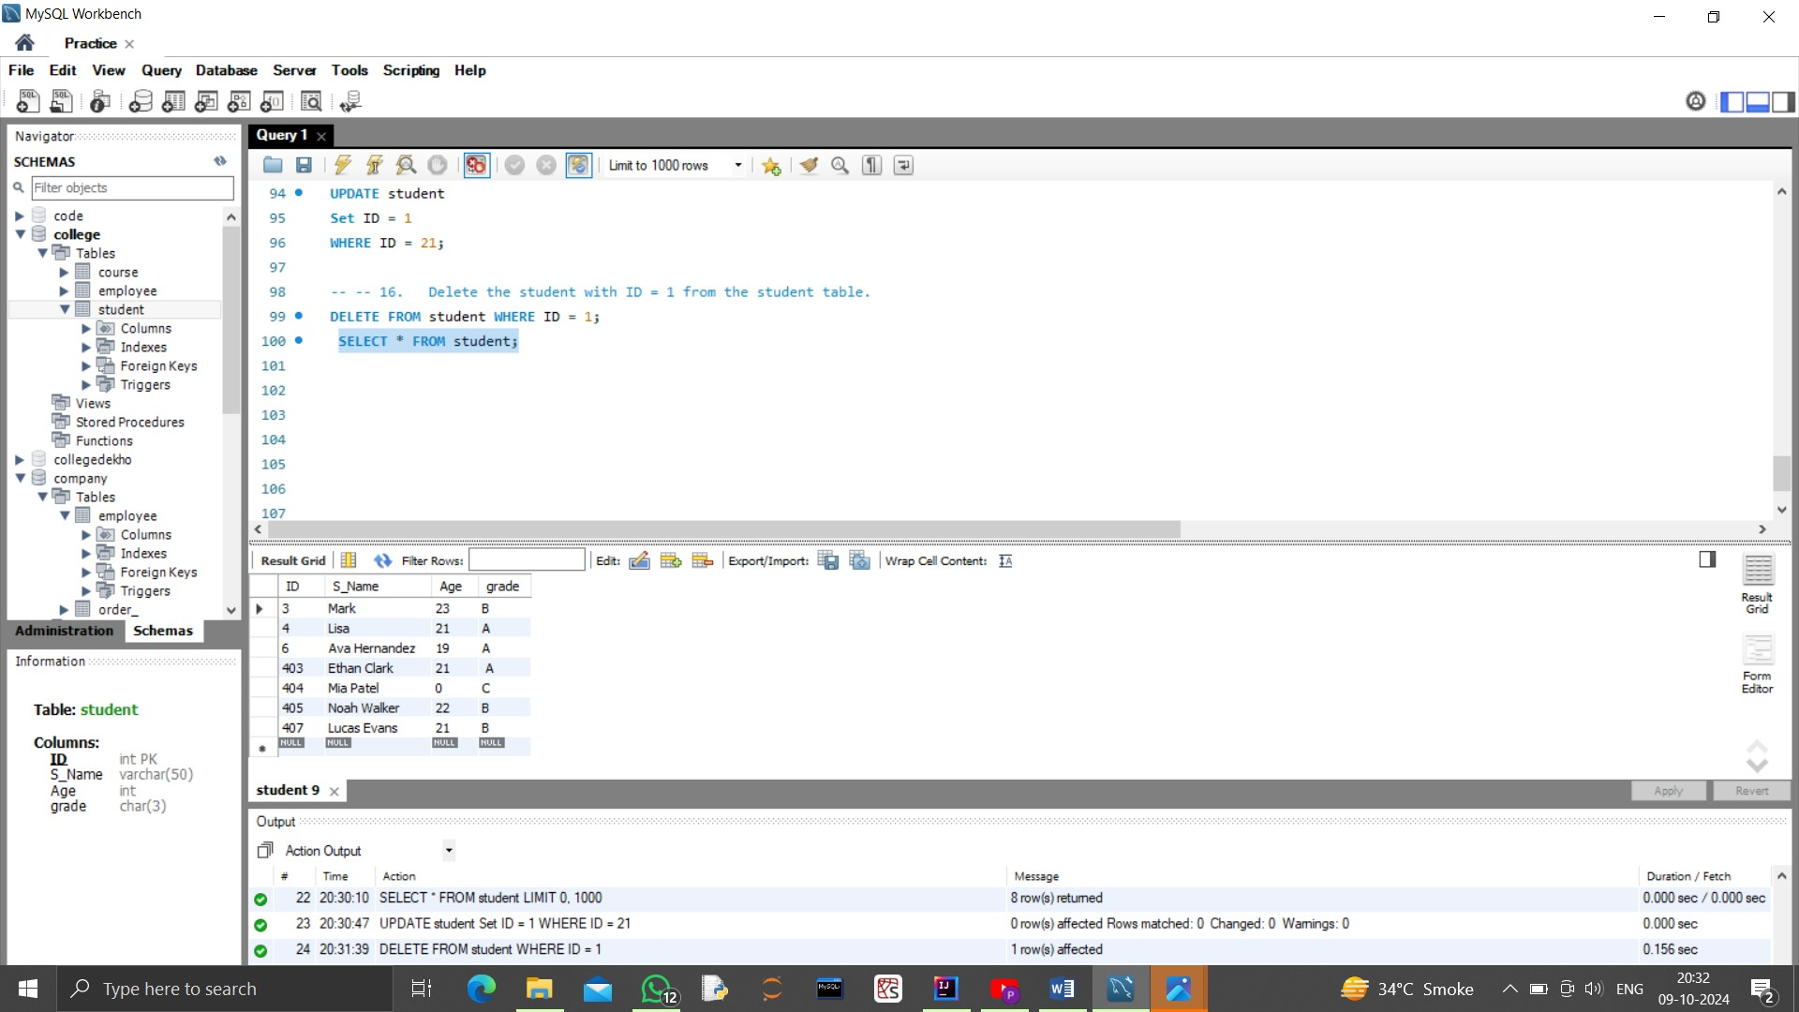**OUTPUT:**

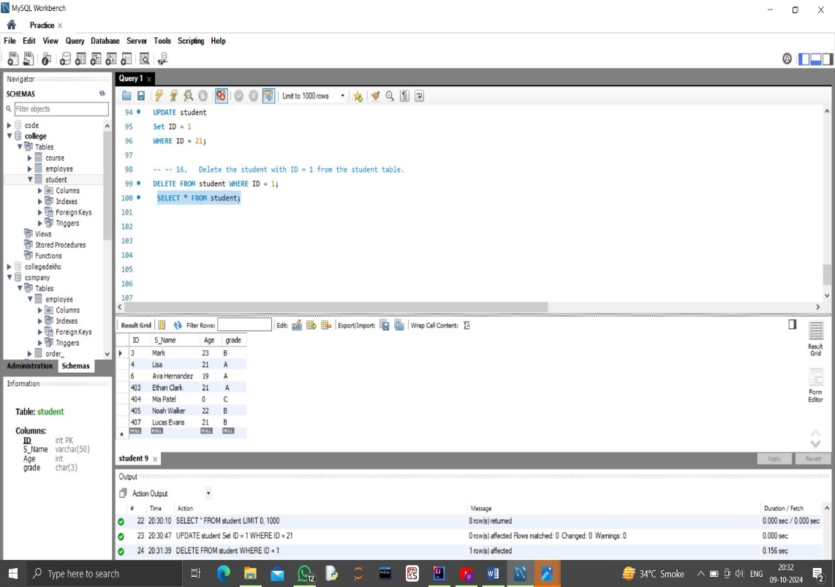

1. **Remove all books from the books table that are priced below 15 dollar**



**ANS ->**

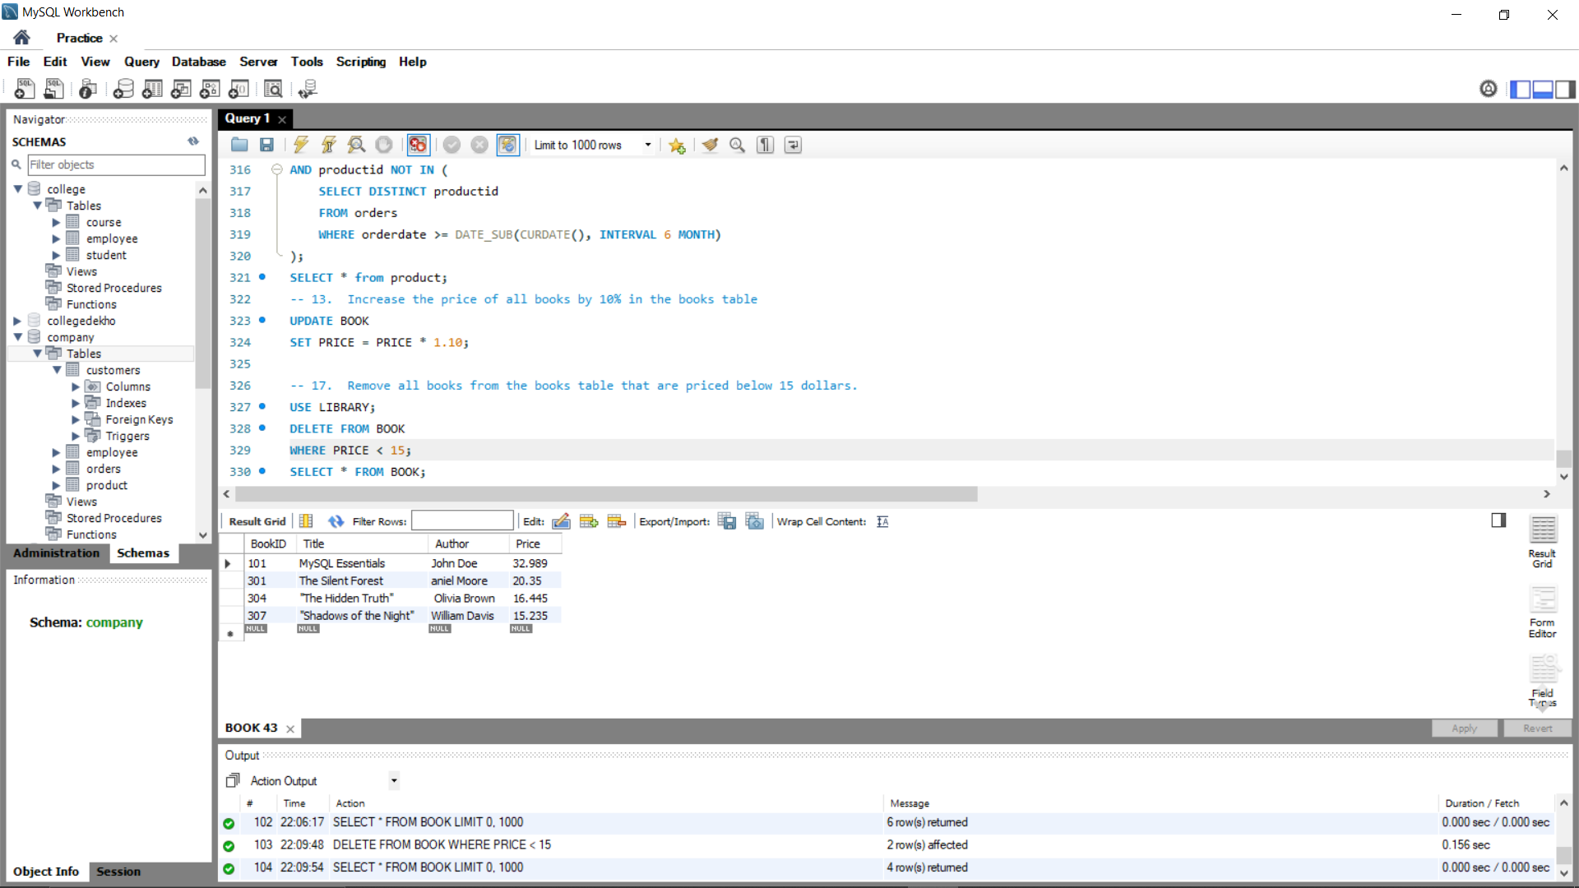

**OUTPUT:-**



1. **Delete all customers who have not placed any orders in the orders table. Ensure no orders exist for those customers before deleting.**



**QUERY-:**

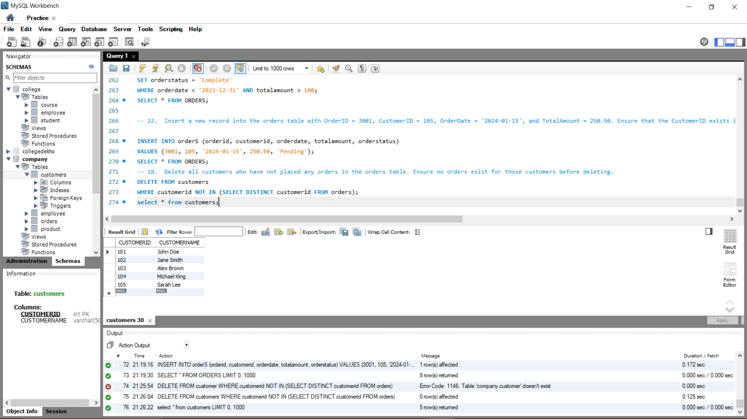

**OUTPUT-:**

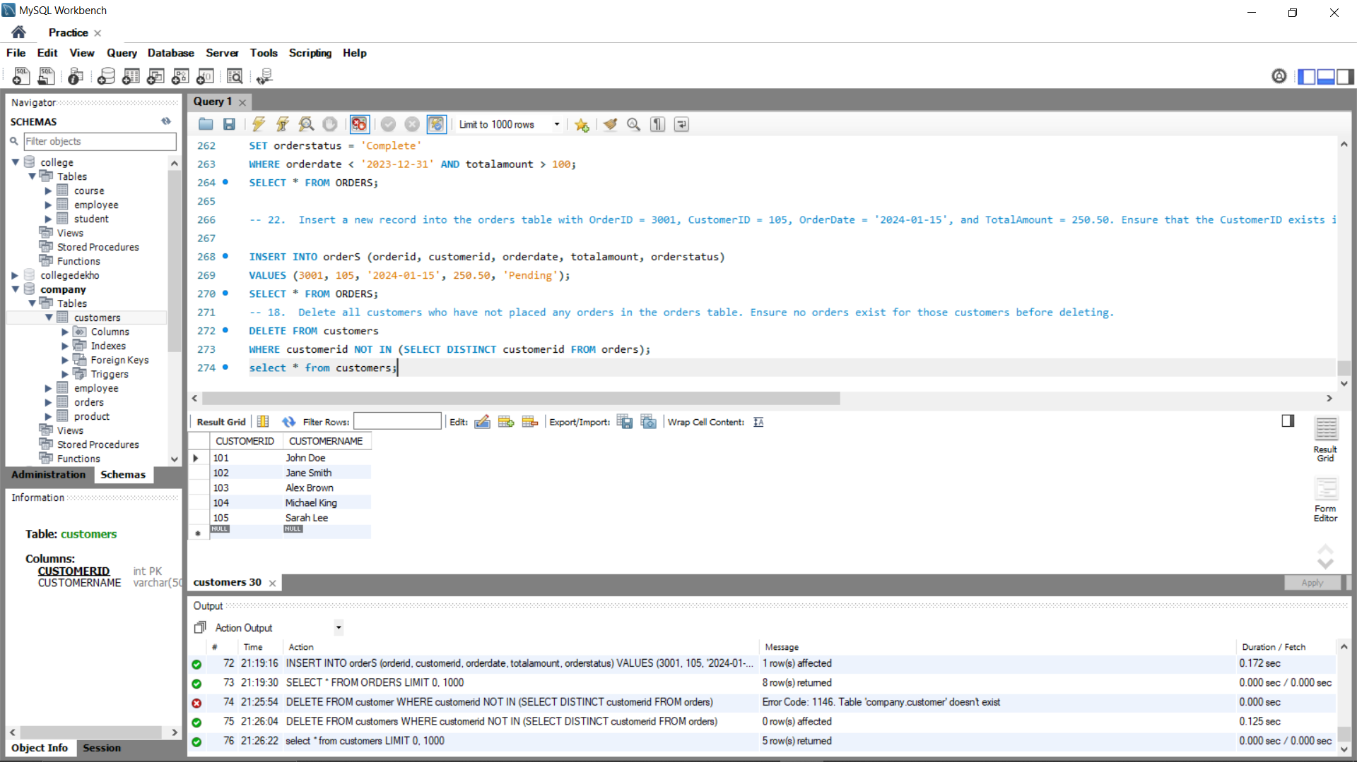

1. **Remove all products from the products table where the StockQuantity is less than 5 and the product has not been ordered in the past 6 months**



**QUERY->**

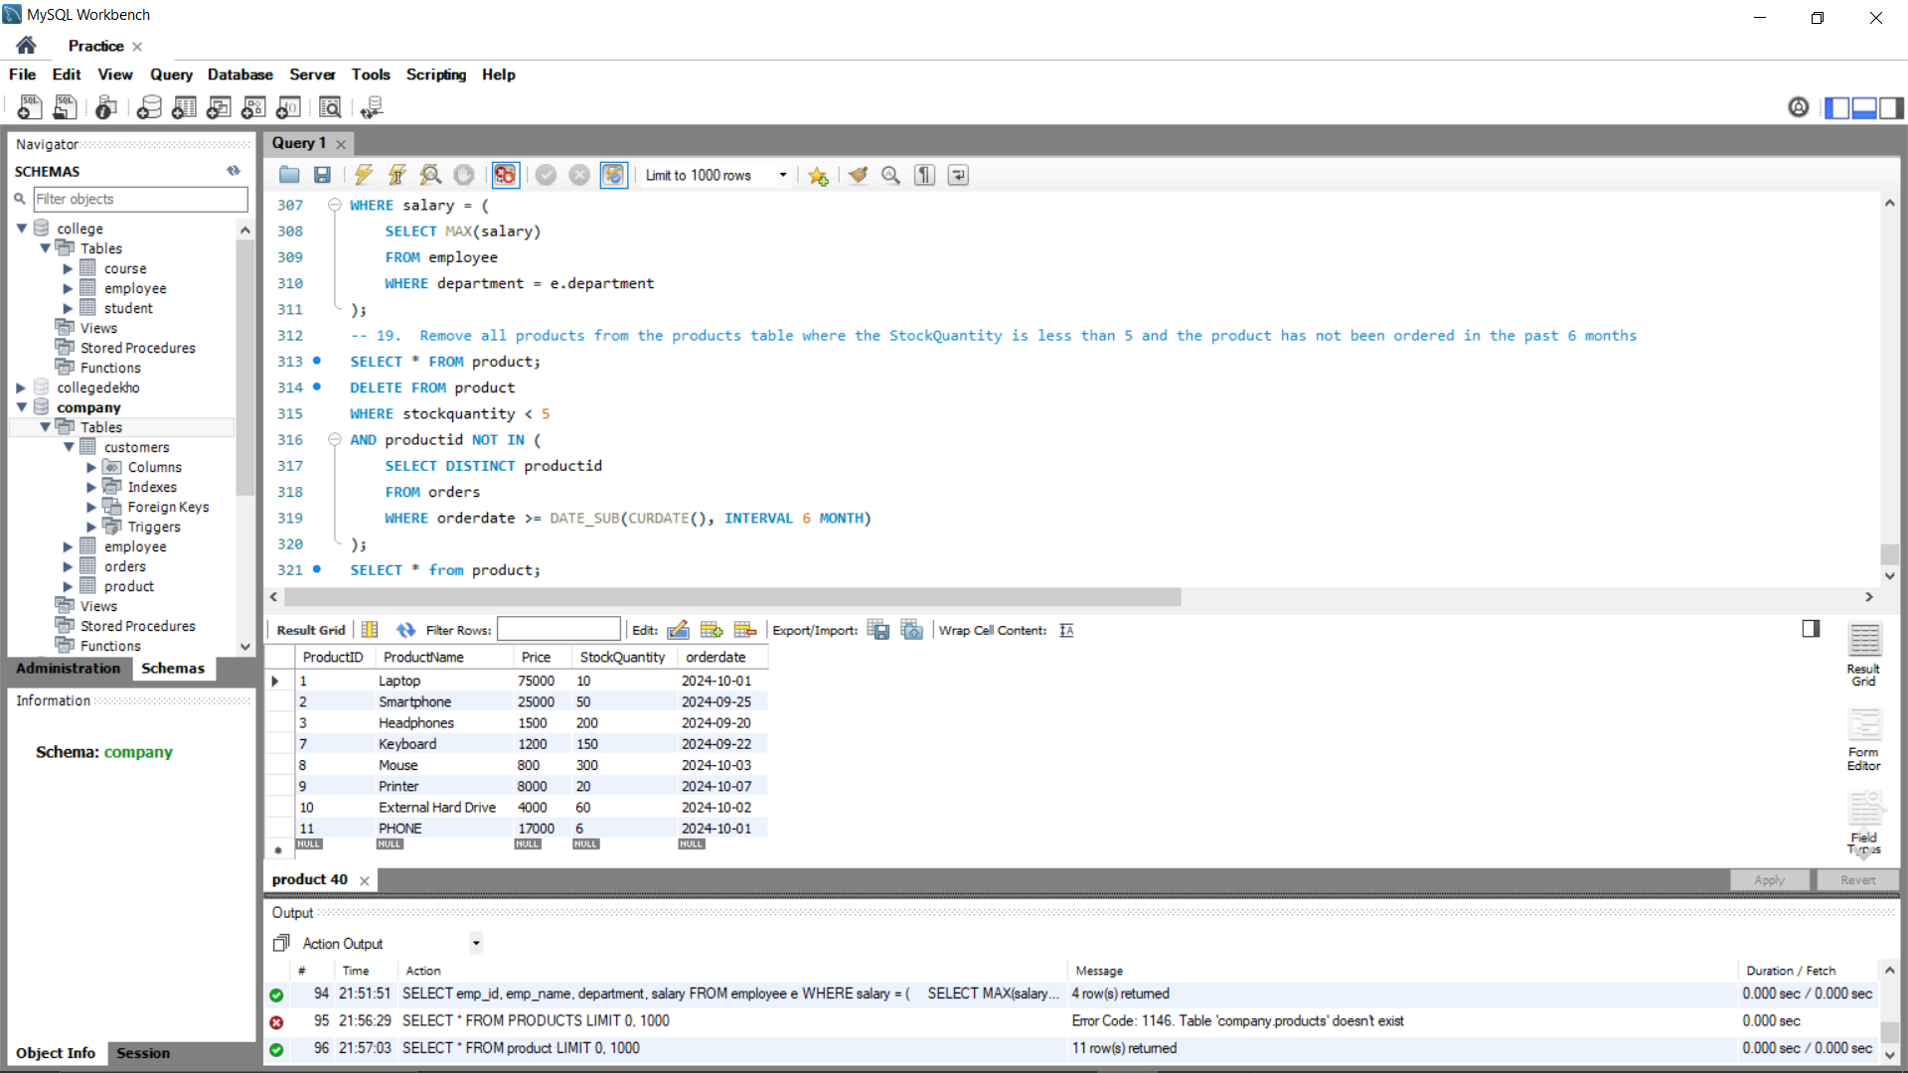

**OUTPUT:-**



1. **Create a new table called courses with the following columns: CourseID, CourseName, and Credits.**

**QUERY ->**

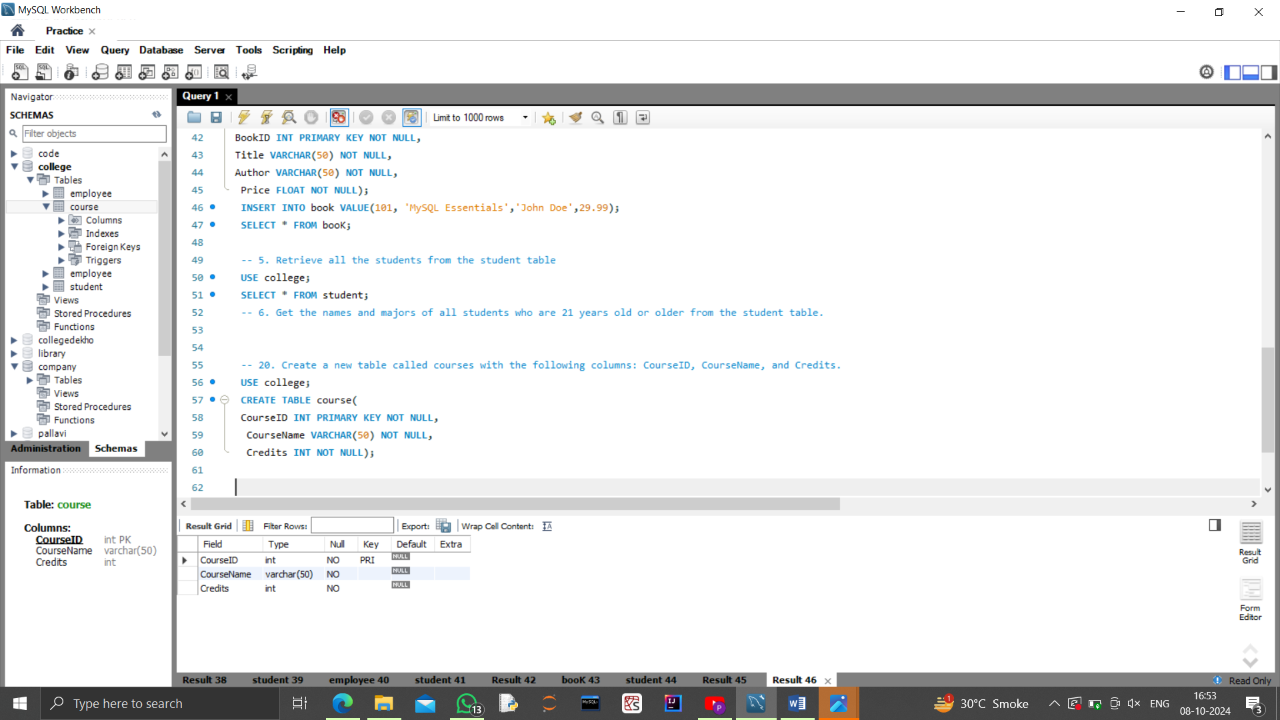

**INPUT:**



**OUTPUT:**



1. **Insert two new courses into the courses table. One with CourseID = 201, CourseName = 'Database Management', and Credits = 3, and another with CourseID = 202, CourseName = 'Web Development', and Credits = 4.**

**ANS->**

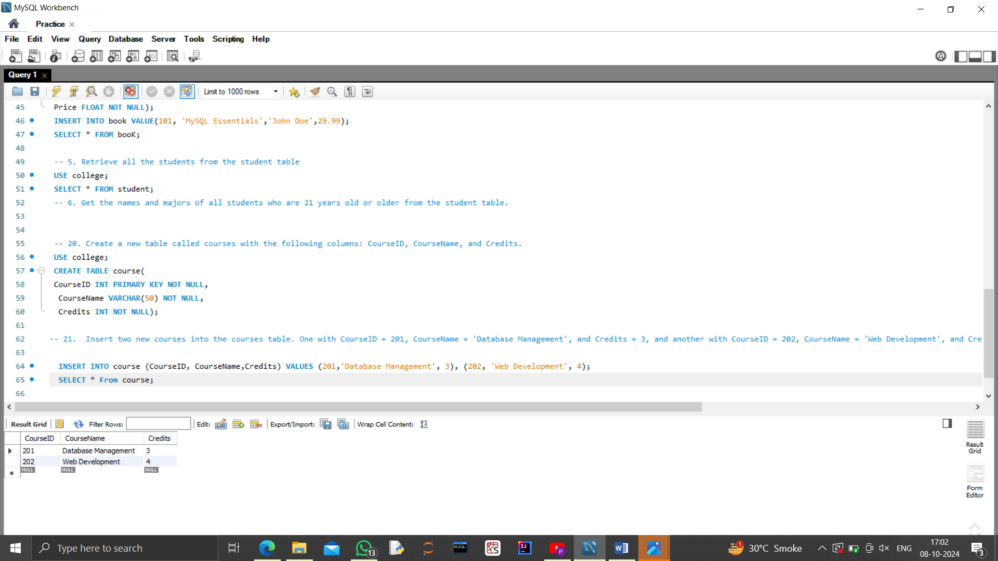

**INPUT:**



**OUTPUT:**



1. **Insert a new record into the orders table with OrderID = 3001, CustomerID = 105, OrderDate = '2024-01-15', and TotalAmount = 250.50. Ensure that the CustomerID exists in the customers table.**



**QUERY-:**

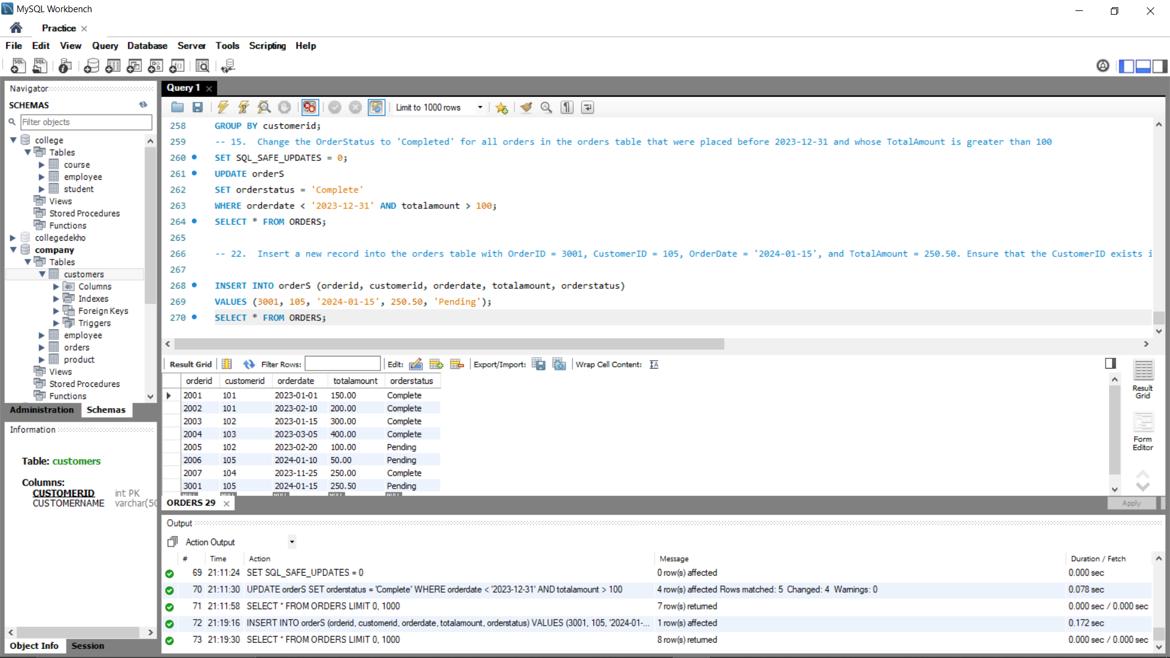

**OUTPUT-:**



1. **the employee who earns the highest salary in each department. Assume there's a DepartmentID in the employees table**

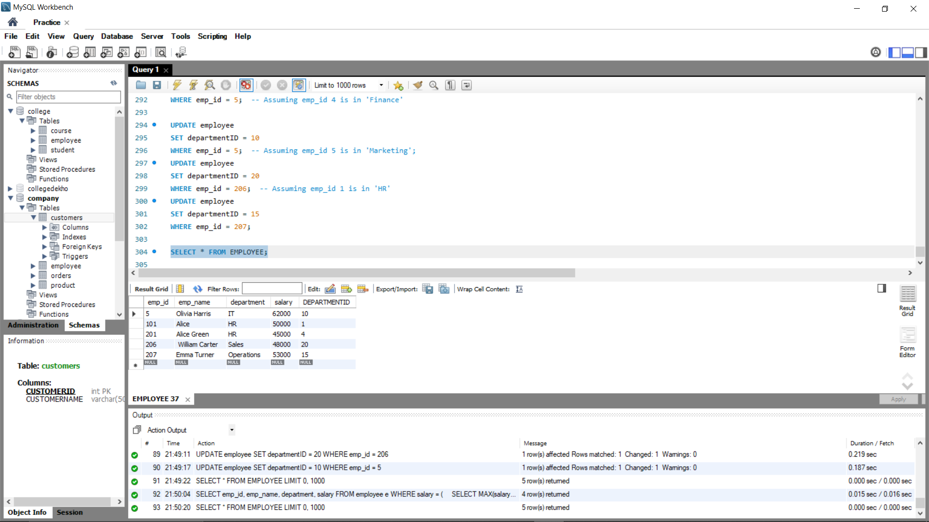

**QUERY-:**

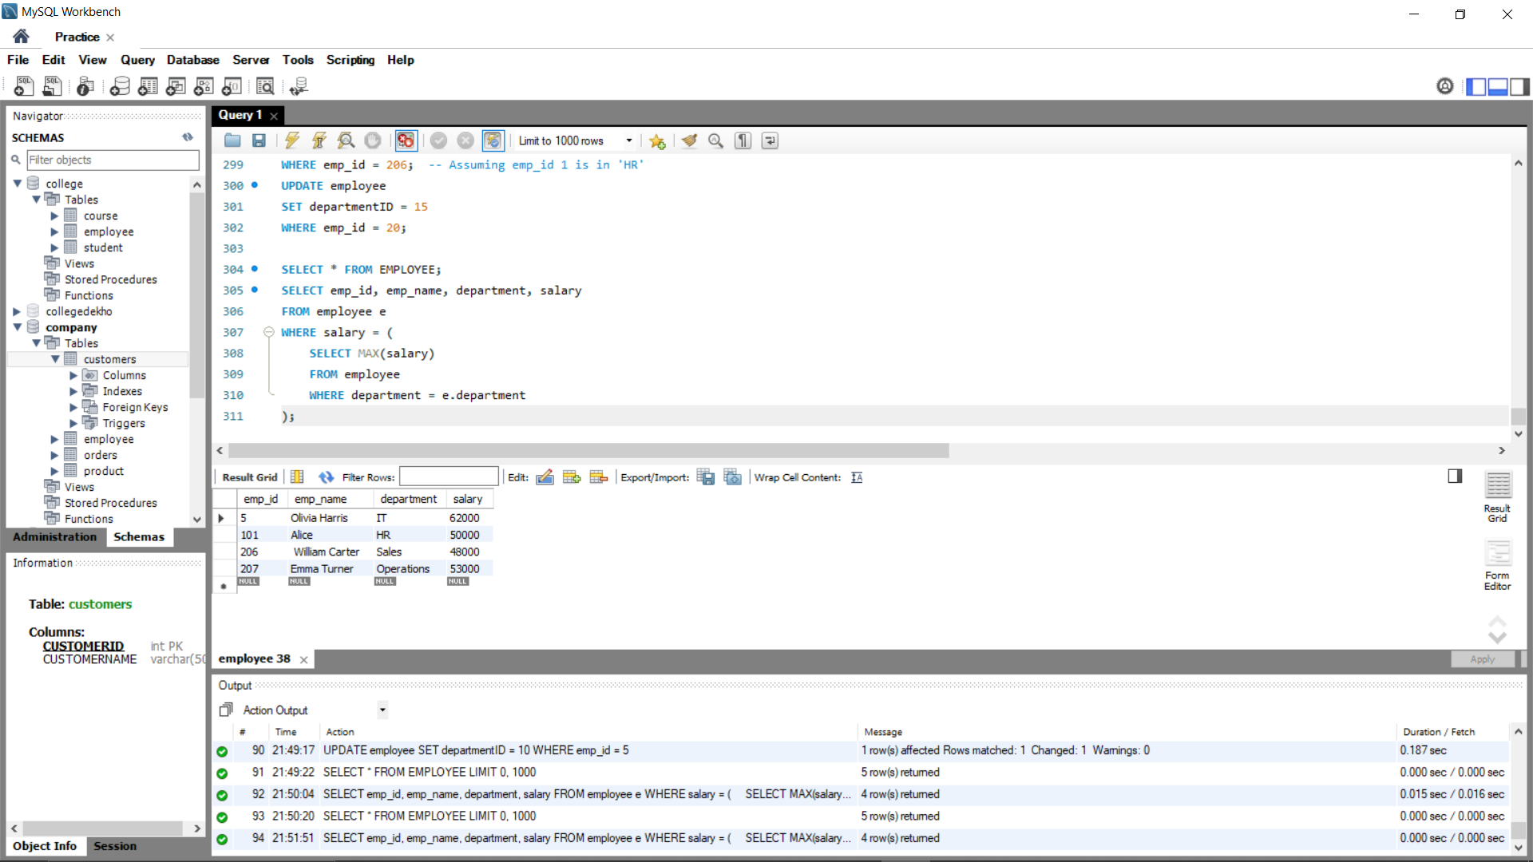

**OUTPUT:-**



1. **Display the CustomerID and TotalAmount for the top 5 largest orders placed in the orders table**.

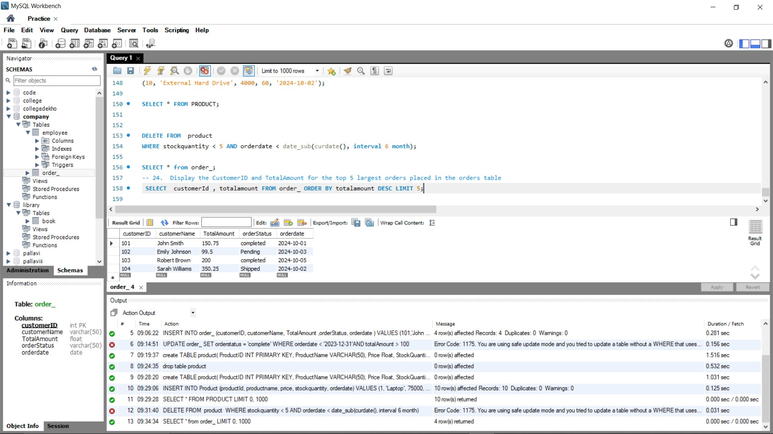

**QUERY->**

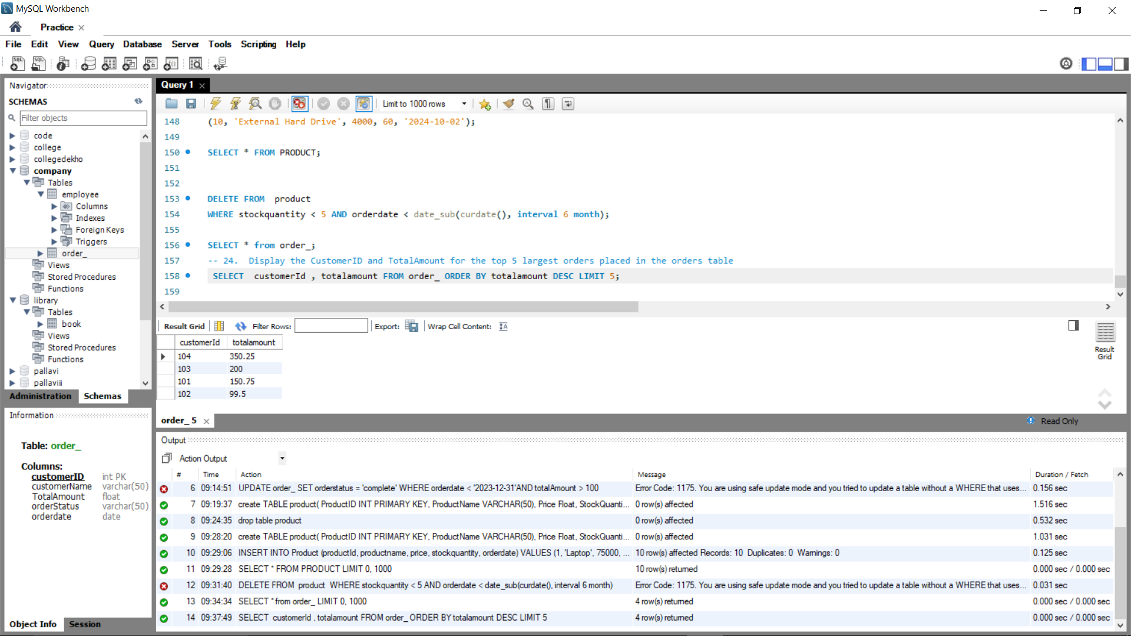

**OUTPUT-:**



**_______________________*****COMPLETE*****___________________________**